**ASSIGNMENT 3**

**Q2**

**ANS-**

Created new DB- Assignment_4

Then created a collections nyse_new

Created index on key: stock_volume in ascending order

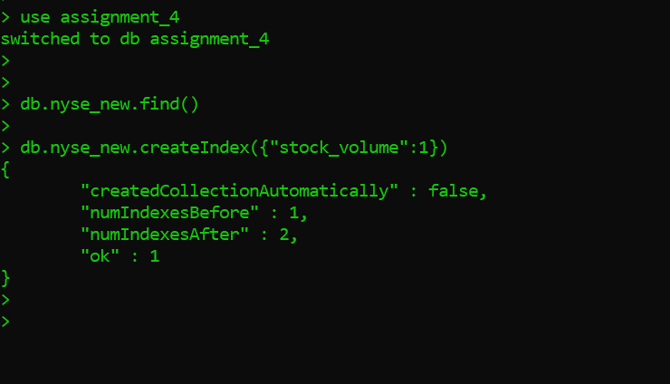

**Then imported the nyse data to this collection using bat file**

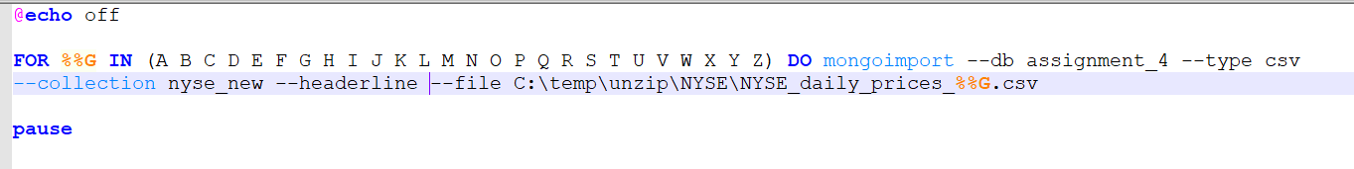

**The indexes are correctly created.**

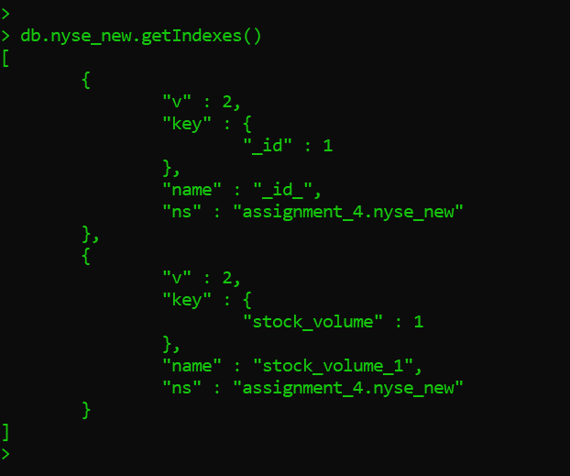

**Q3**

**Ans—**

**Imported all the nyse data to new collection stocks**

**Then after that created index** on key: stock_symbol in ascending order

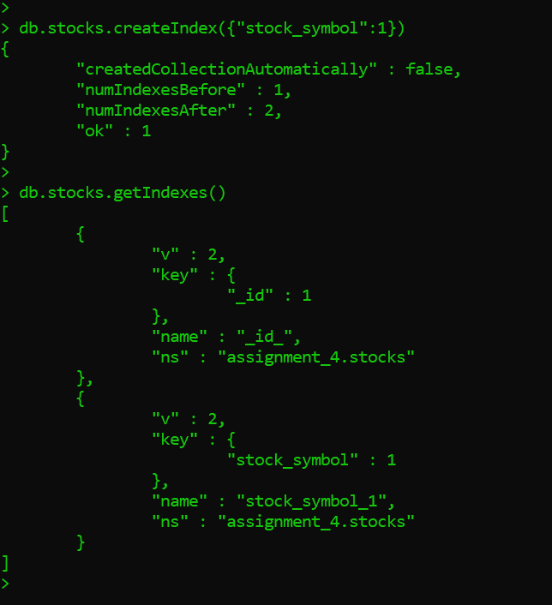

**Q4**

**Ans:**

* appendToFile
* cat



* [checksum](http://hadoop.apache.org/docs/current/hadoop-project-dist/hadoop-common/FileSystemShell.html#checksum)



* [chgrp](http://hadoop.apache.org/docs/current/hadoop-project-dist/hadoop-common/FileSystemShell.html#chgrp)

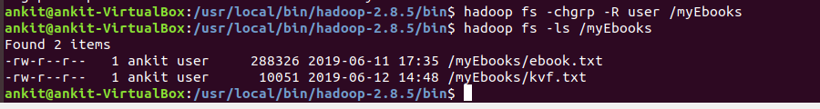

* [chmod](http://hadoop.apache.org/docs/current/hadoop-project-dist/hadoop-common/FileSystemShell.html#chmod)

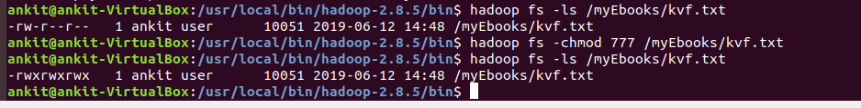

* [chown](http://hadoop.apache.org/docs/current/hadoop-project-dist/hadoop-common/FileSystemShell.html#chown)

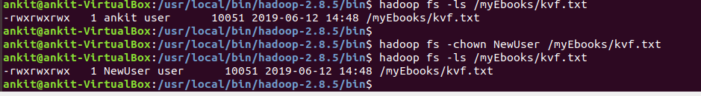

* [copyFromLocal](http://hadoop.apache.org/docs/current/hadoop-project-dist/hadoop-common/FileSystemShell.html#copyFromLocal)

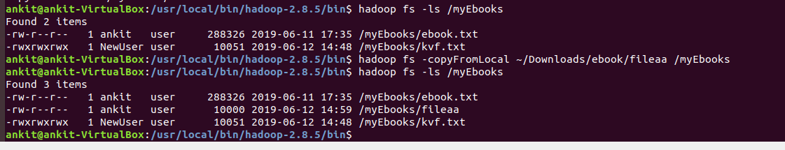

* [copyToLocal](http://hadoop.apache.org/docs/current/hadoop-project-dist/hadoop-common/FileSystemShell.html#copyToLocal)



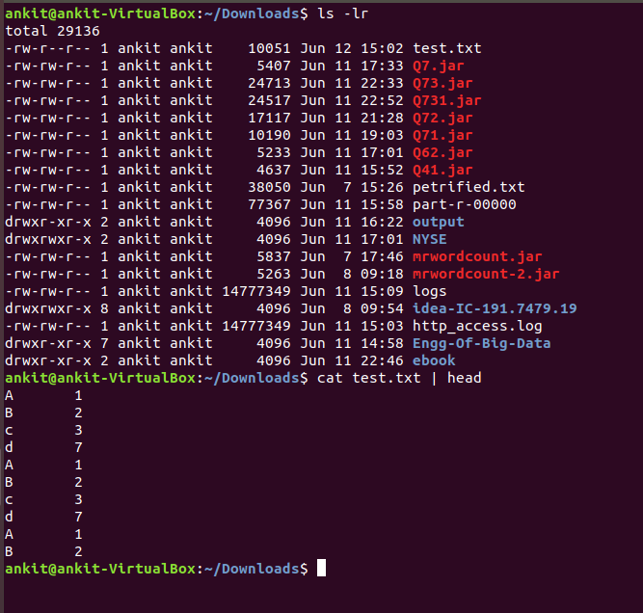

* [count](http://hadoop.apache.org/docs/current/hadoop-project-dist/hadoop-common/FileSystemShell.html#count)

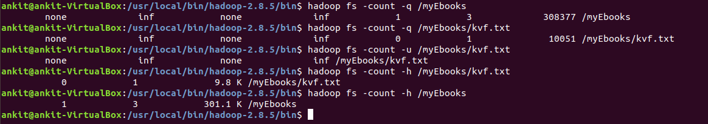

* [cp](http://hadoop.apache.org/docs/current/hadoop-project-dist/hadoop-common/FileSystemShell.html#cp)

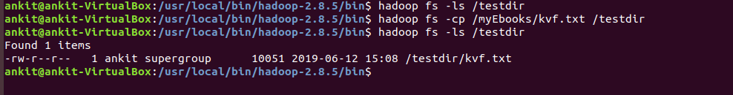

* [createSnapshot](http://hadoop.apache.org/docs/current/hadoop-project-dist/hadoop-common/FileSystemShell.html#createSnapshot)

Create a snapshot of a snapshottable directory. This operation requires owner privilege of the snapshottable directory.

**Command:**

hdfs dfs -createSnapshot <path> [<snapshotName>]

* [deleteSnapshot](http://hadoop.apache.org/docs/current/hadoop-project-dist/hadoop-common/FileSystemShell.html#deleteSnapshot)

Delete a snapshot of from a snapshottable directory. This operation requires owner privilege of the snapshottable directory.

**Command:**

hdfs dfs -deleteSnapshot <path> <snapshotName>

* [df](http://hadoop.apache.org/docs/current/hadoop-project-dist/hadoop-common/FileSystemShell.html#df)

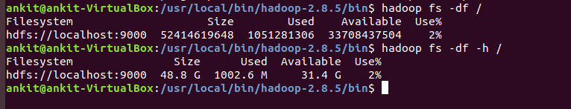

* [du](http://hadoop.apache.org/docs/current/hadoop-project-dist/hadoop-common/FileSystemShell.html#du)

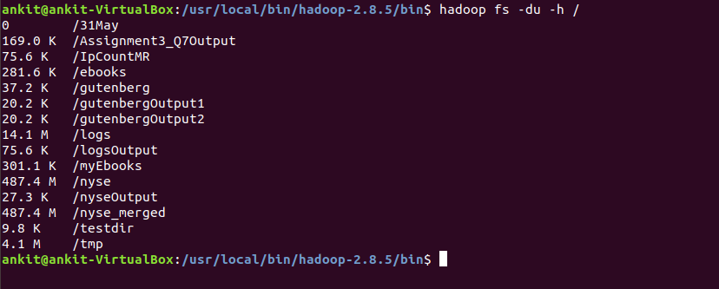

* [dus](http://hadoop.apache.org/docs/current/hadoop-project-dist/hadoop-common/FileSystemShell.html#dus)

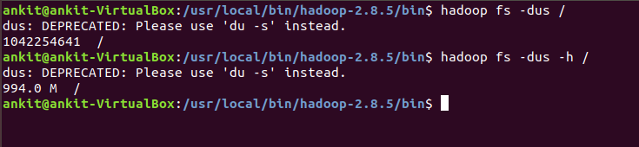

* [expunge](http://hadoop.apache.org/docs/current/hadoop-project-dist/hadoop-common/FileSystemShell.html#expunge)

Usage: hadoop fs -expunge

Permanently delete files in checkpoints older than the retention threshold from trash directory, and create new checkpoint.

When checkpoint is created, recently deleted files in trash are moved under the checkpoint. Files in checkpoints older than fs.trash.interval will be permanently deleted on the next invocation of -expunge command.

* [find](http://hadoop.apache.org/docs/current/hadoop-project-dist/hadoop-common/FileSystemShell.html#find)

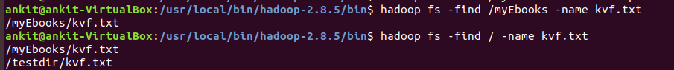

* [get](http://hadoop.apache.org/docs/current/hadoop-project-dist/hadoop-common/FileSystemShell.html#get)



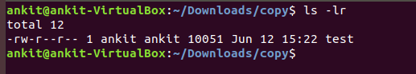

* [getfacl](http://hadoop.apache.org/docs/current/hadoop-project-dist/hadoop-common/FileSystemShell.html#getfacl)

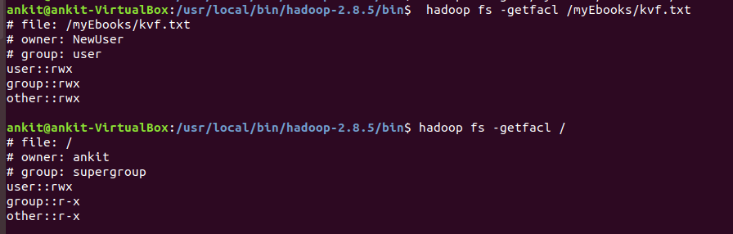

* [getfattr](http://hadoop.apache.org/docs/current/hadoop-project-dist/hadoop-common/FileSystemShell.html#getfattr)

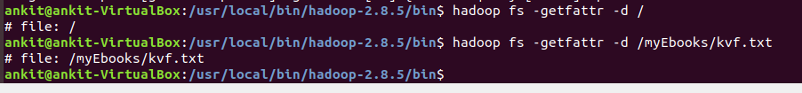

* [getmerge](http://hadoop.apache.org/docs/current/hadoop-project-dist/hadoop-common/FileSystemShell.html#getmerge)



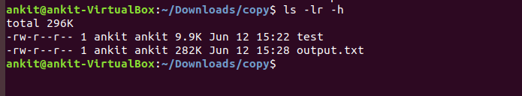

* [help](http://hadoop.apache.org/docs/current/hadoop-project-dist/hadoop-common/FileSystemShell.html#help)

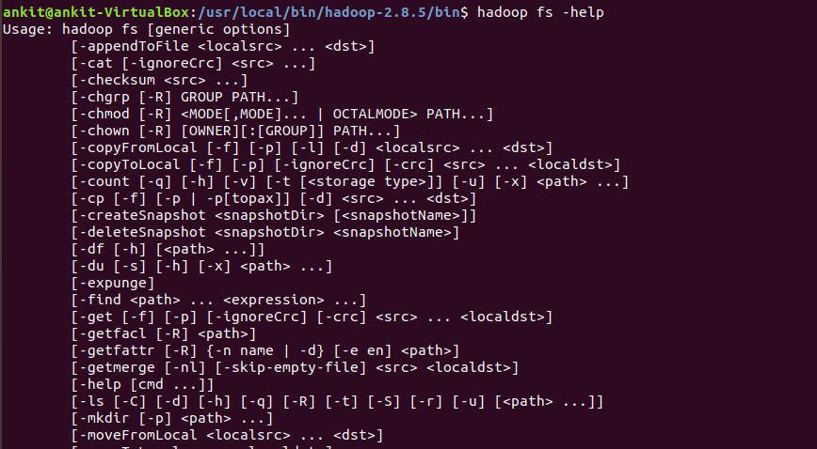

* [ls](http://hadoop.apache.org/docs/current/hadoop-project-dist/hadoop-common/FileSystemShell.html#ls)

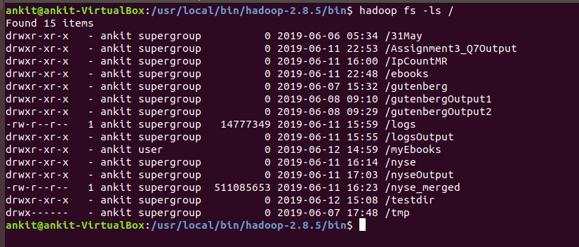

* [lsr](http://hadoop.apache.org/docs/current/hadoop-project-dist/hadoop-common/FileSystemShell.html#lsr)

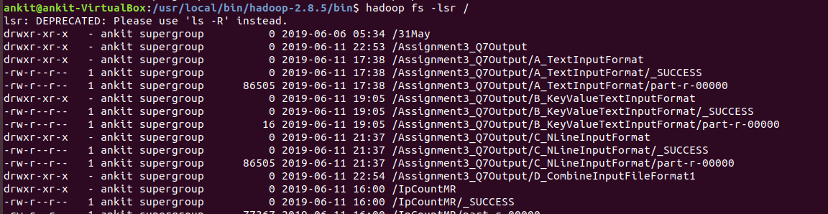

* [mkdir](http://hadoop.apache.org/docs/current/hadoop-project-dist/hadoop-common/FileSystemShell.html#mkdir)

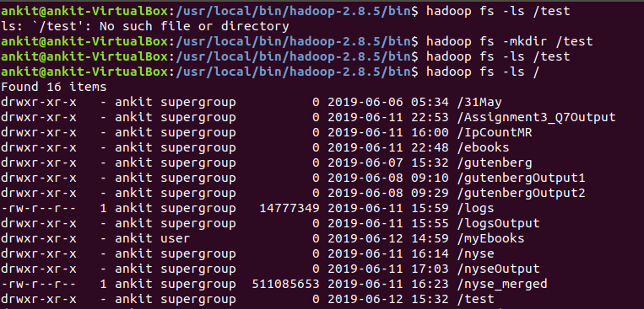

* [moveFromLocal](http://hadoop.apache.org/docs/current/hadoop-project-dist/hadoop-common/FileSystemShell.html#moveFromLocal)

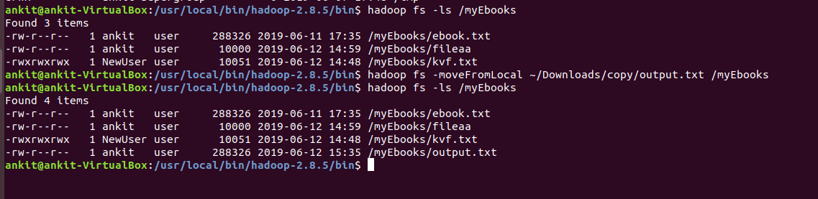

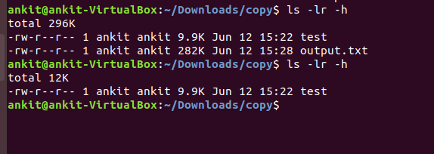

* [moveToLocal](http://hadoop.apache.org/docs/current/hadoop-project-dist/hadoop-common/FileSystemShell.html#moveToLocal)



* [mv](http://hadoop.apache.org/docs/current/hadoop-project-dist/hadoop-common/FileSystemShell.html#mv)

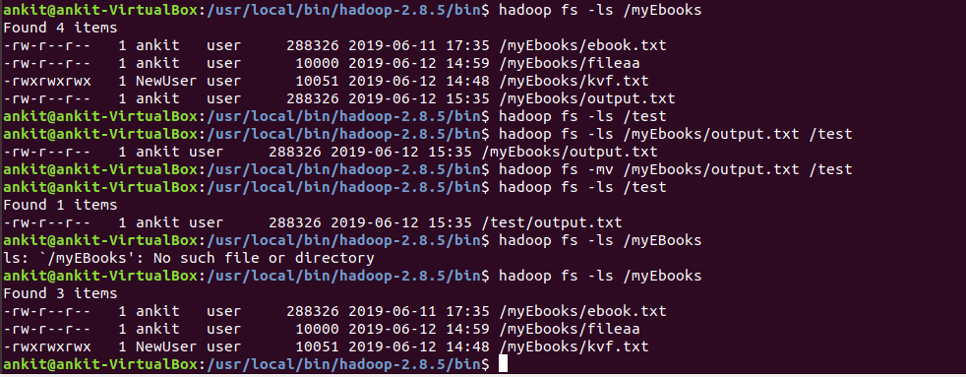

* [put](http://hadoop.apache.org/docs/current/hadoop-project-dist/hadoop-common/FileSystemShell.html#put)

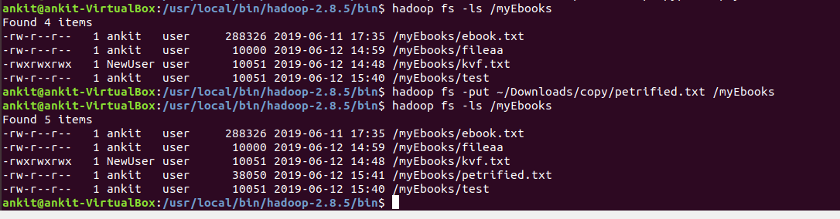

* [renameSnapshot](http://hadoop.apache.org/docs/current/hadoop-project-dist/hadoop-common/FileSystemShell.html#renameSnapshot)

Rename a snapshot. This operation requires owner privilege of the snapshottable directory.

**Command:**

hdfs dfs -renameSnapshot <path> <oldName> <newName>

* [rm](http://hadoop.apache.org/docs/current/hadoop-project-dist/hadoop-common/FileSystemShell.html#rm)

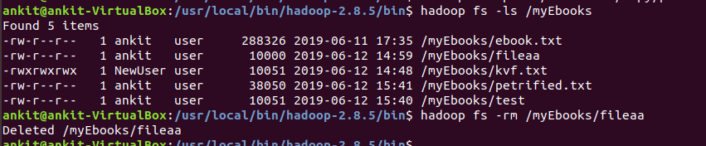

* [rmdir](http://hadoop.apache.org/docs/current/hadoop-project-dist/hadoop-common/FileSystemShell.html#rmdir)

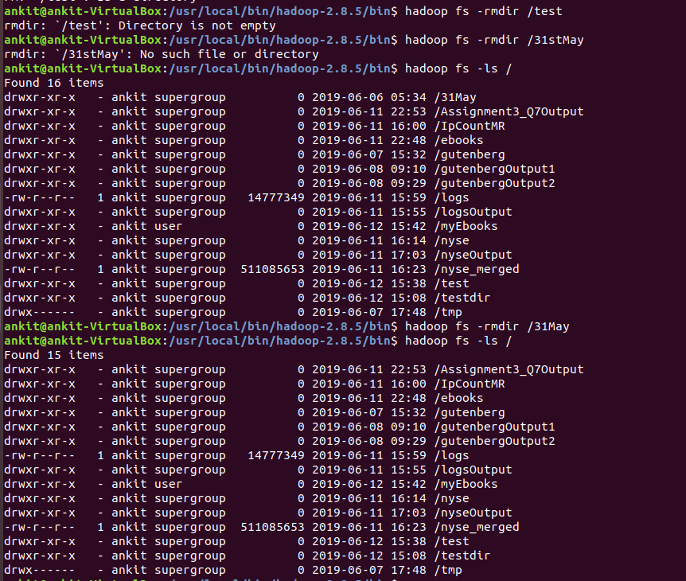

* [rmr](http://hadoop.apache.org/docs/current/hadoop-project-dist/hadoop-common/FileSystemShell.html#rmr)

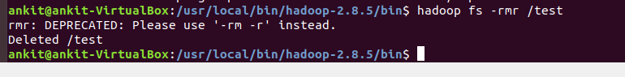

* [setfacl](http://hadoop.apache.org/docs/current/hadoop-project-dist/hadoop-common/FileSystemShell.html#setfacl)

Usage: hadoop fs -setfacl [-R] [-b |-k -m |-x <acl_spec> <path>] |[--set <acl_spec> <path>]

Sets Access Control Lists (ACLs) of files and directories.

* [setfattr](http://hadoop.apache.org/docs/current/hadoop-project-dist/hadoop-common/FileSystemShell.html#setfattr)

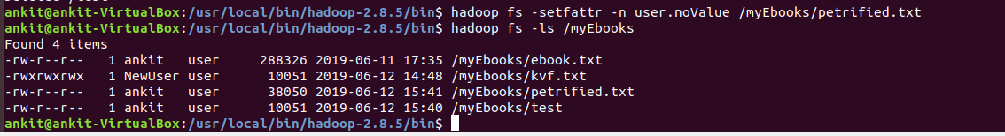

* [setrep](http://hadoop.apache.org/docs/current/hadoop-project-dist/hadoop-common/FileSystemShell.html#setrep)



* [stat](http://hadoop.apache.org/docs/current/hadoop-project-dist/hadoop-common/FileSystemShell.html#stat)



* [tail](http://hadoop.apache.org/docs/current/hadoop-project-dist/hadoop-common/FileSystemShell.html#tail)

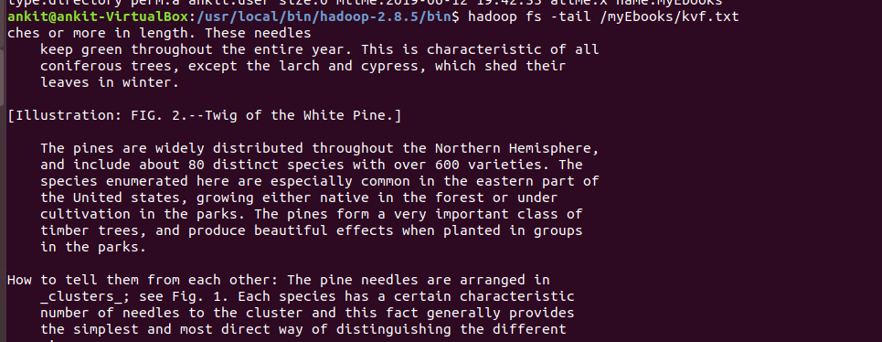

* [test](http://hadoop.apache.org/docs/current/hadoop-project-dist/hadoop-common/FileSystemShell.html#test)

Usage: hadoop fs -test -[defsz] URI

Options:

-d: f the path is a directory, return 0.

-e: if the path exists, return 0.

-f: if the path is a file, return 0.

-s: if the path is not empty, return 0.

-r: if the path exists and read permission is granted, return 0.

-w: if the path exists and write permission is granted, return 0.

-z: if the file is zero length, return 0.

Example:

hadoop fs -test -e filename



* [text](http://hadoop.apache.org/docs/current/hadoop-project-dist/hadoop-common/FileSystemShell.html#text)

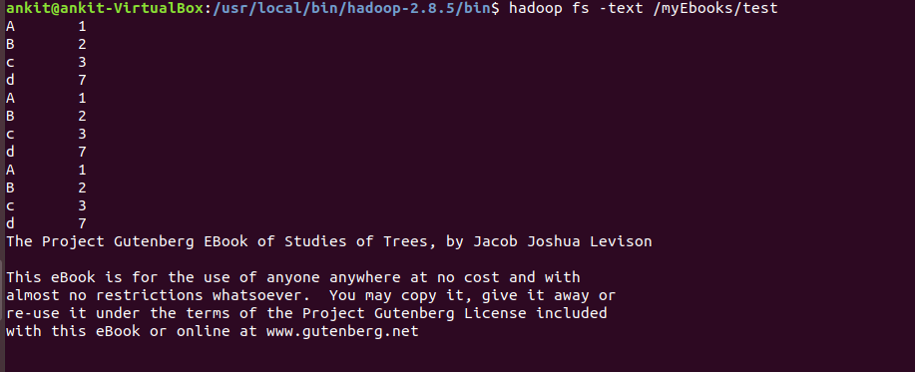

* [touchz](http://hadoop.apache.org/docs/current/hadoop-project-dist/hadoop-common/FileSystemShell.html#touchz)

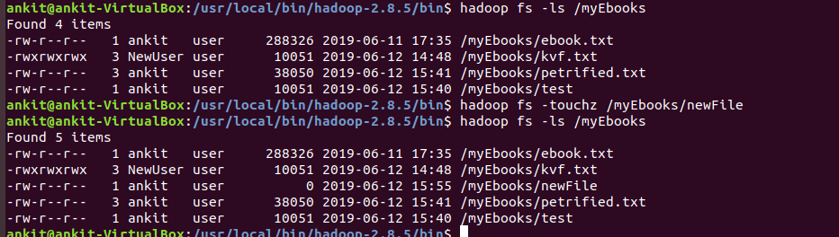

* [truncate](http://hadoop.apache.org/docs/current/hadoop-project-dist/hadoop-common/FileSystemShell.html#truncate)

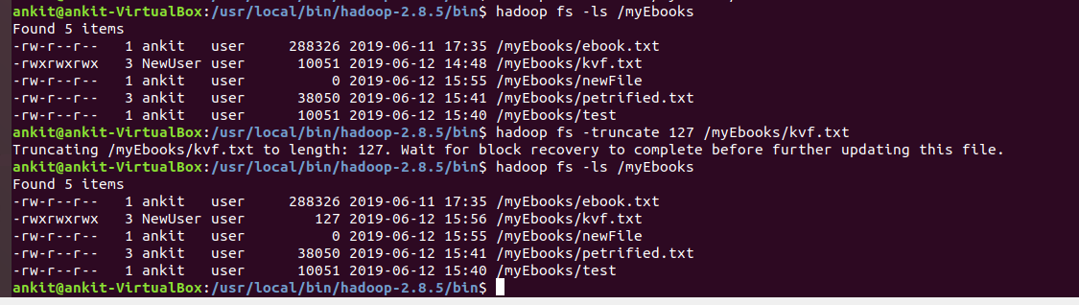

* [usage](http://hadoop.apache.org/docs/current/hadoop-project-dist/hadoop-common/FileSystemShell.html#usage)

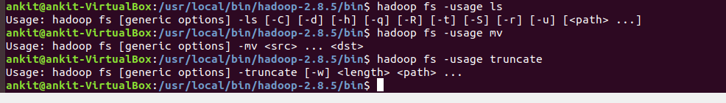

**Q5**

**Ans--**

**copy http_access.log to /logs**

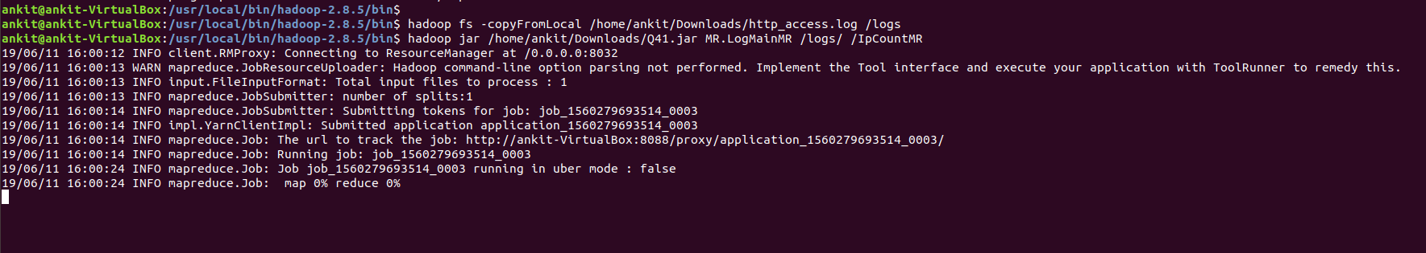

Also ran MAP reduce on the logs to count the number of time ip is used

The program folder is inside the Assignment folder

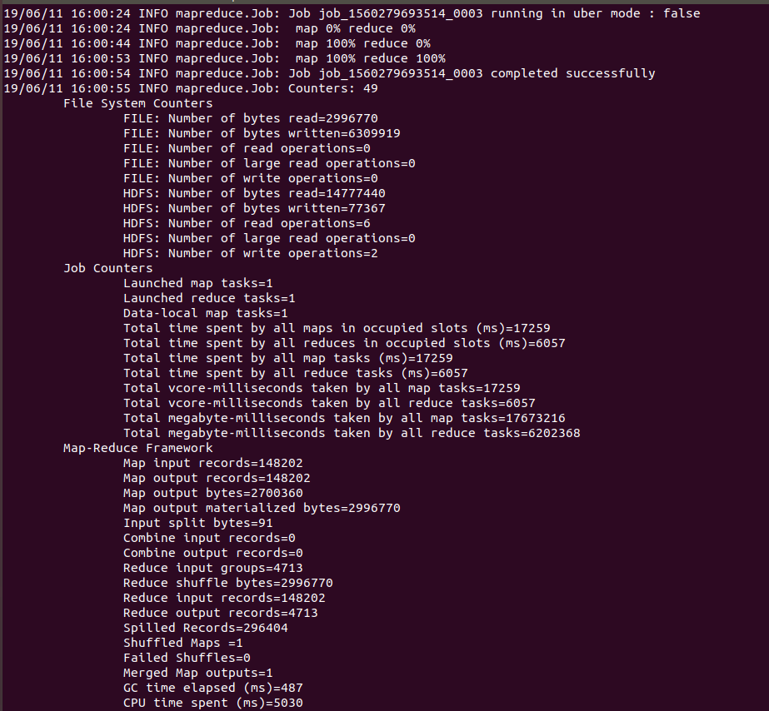Output head is as follows

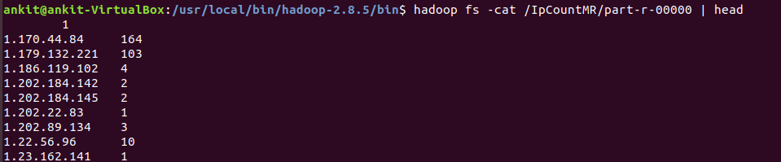

Q6

Ans--

Download and Copy all the files (http://msis.neu.edu/nyse/) (DailyPrices_A to DailyPrices_Z) to a folder in HDFS.

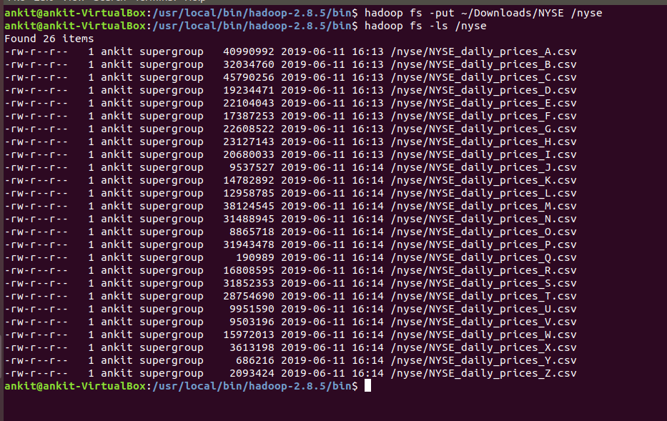

Merging all records in single file and saving in HDFS

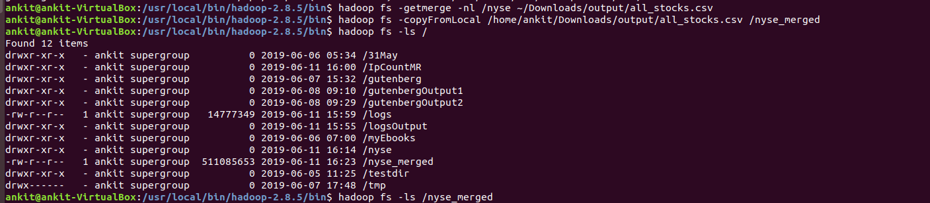

The java program is in the assignment folder

Output of MapReduce for maximum stock_price_high for each stock is as follows:

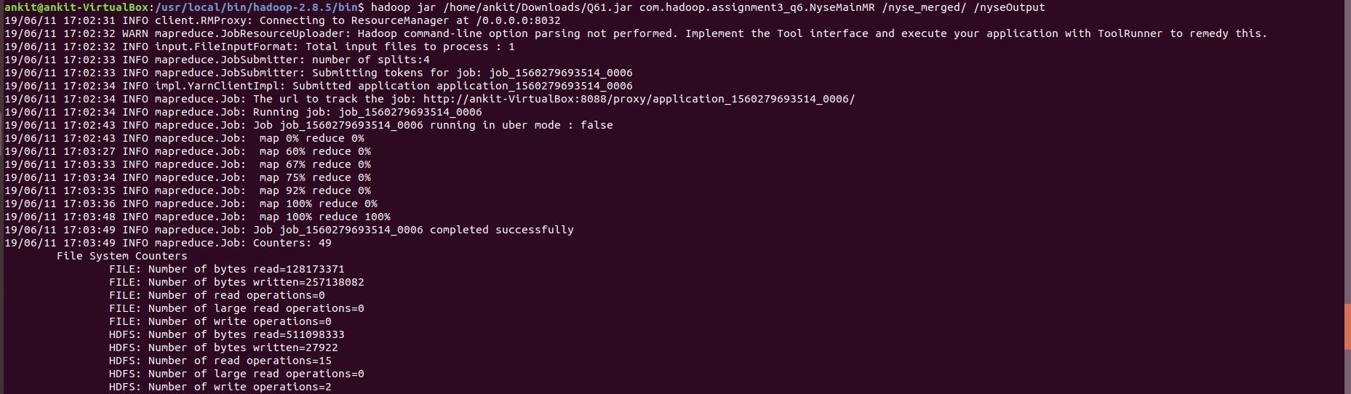

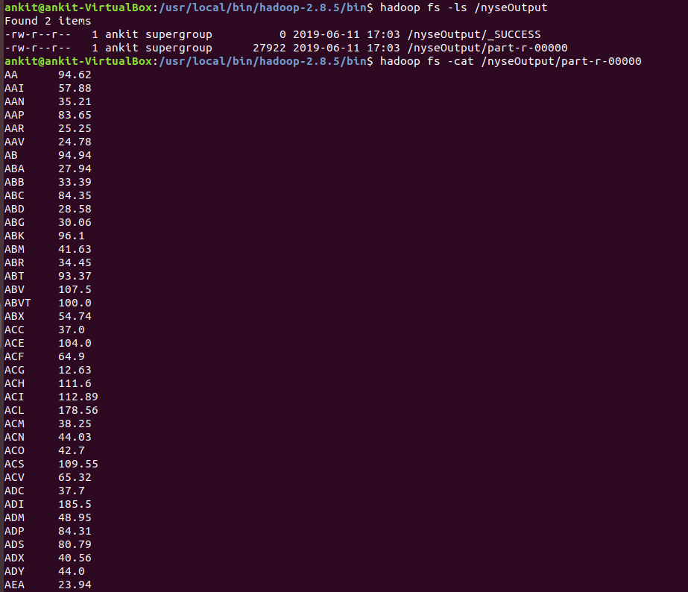

Q7

Ans--

**1> TextInputFormat**

Code in package textInputFormat

Output

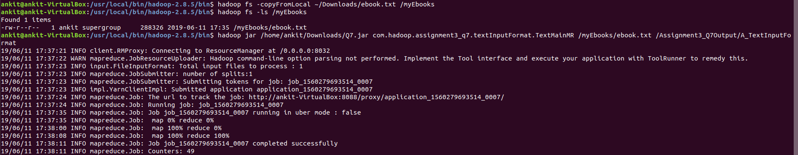



**2> SequenceFileInputFormat**

**3>KeyValueTextInputFormat**

Operation- Counting the number of keys

code in package KeyValueInputFormat

**Output**

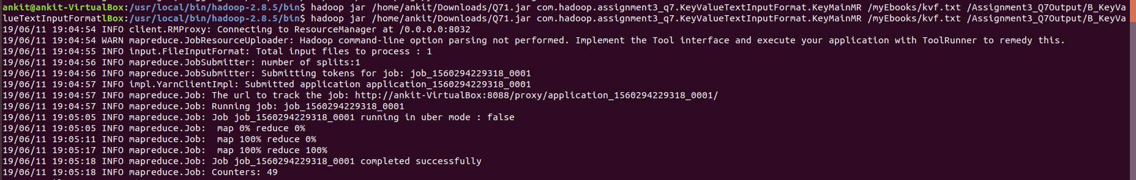

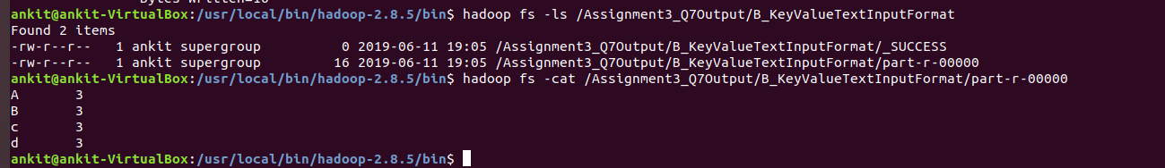

**4> FixedLengthInputFormat**

**5> NlineInputFormat**

**The code is in package NlineInputFormat**

**Output**

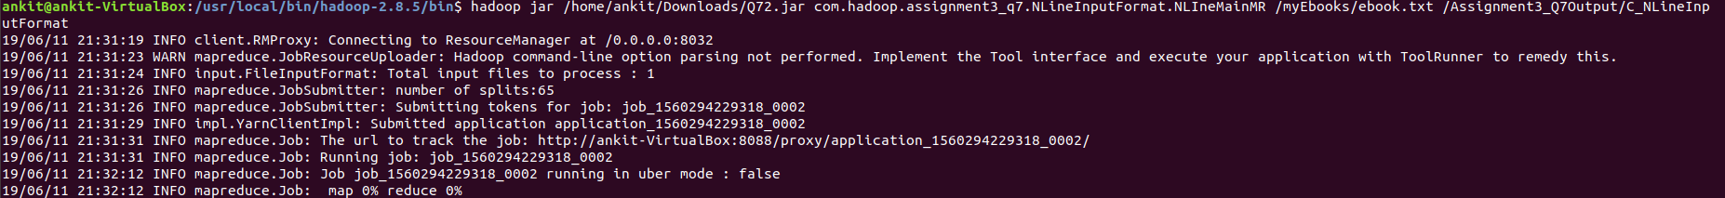

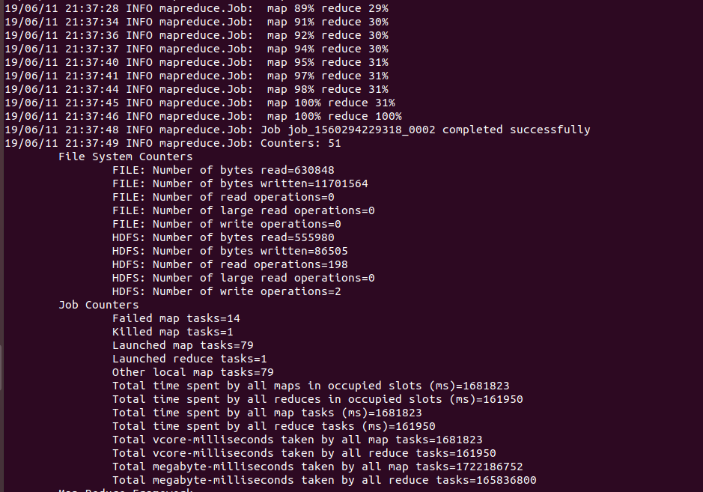

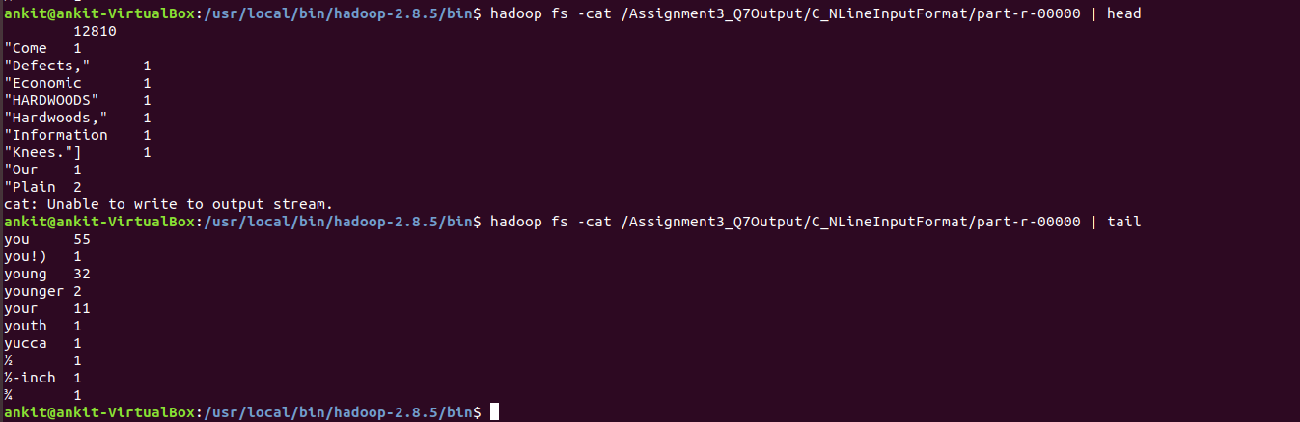

**6 CombineFileInputFormat**